
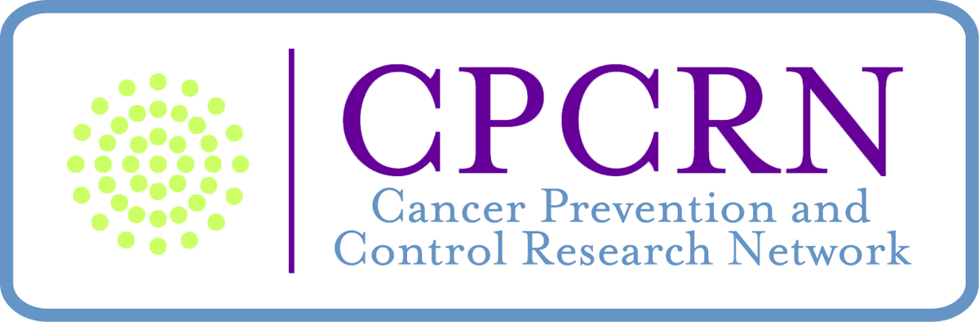

Tools for Communities to Implement and Adapt Evidence

RESOURCE LIST

Emory CPCRN Prevention Programs that Work Training
http://www.sph.emory.edu/eprc/minigrant/2010training.html

NCI Cancer Control P.L.A.N.E.T. - Research to Reality Cyber-Seminar Series
http://cancercontrolplanet.cancer.gov/cyber-seminars.html

Evidence-Based Program Resources
- Agency for Healthcare Quality and Research (AHQR)
http://www.ahrq.gov/
- Centre for Reviews and Dissemination Databases (University of York, UK)
http://www.crd.york.ac.uk/crdweb/
- Cochrane Collaborative
http://www.cochrane.org
- UNC Center of Excellence for Training and Research Translation
http://www.center-trt.org/index.cfm
- EPPI (Evidence for Practice and Policy Information) Centre at Social Science Research Unit, Institute of Education, University of London, UK
http://eppi.ioe.ac.uk/cms/
- Evidence Based Practice for Public Health
http://library.umassmed.edu/ebpph/
- From Evidence to Practice: Using a systematic approach to address disparities in birth outcomes. (New York State Department of Health)
http://www.ebph.org/overview.cfm
- Health-Evidence.ca (Canadian Institutes of Health Research)
http://health-evidence.ca/
- National Guideline Clearinghouse (Clinical Guidelines)
http://www.ngc.gov/
- MICA (Missouri Information for Community Assessment)
http://www.dhss.mo.gov/InterventionMICA/index.html
- Model Practices Database (National Association of County and City Health Officials)
http://www.naccho.org/topics/modelpractices/
- Partnership for Prevention Action Guides
http://www.prevent.org/Initiatives/Action-Guides.aspx
- Prevention Institute (ENACT)
http://www.preventioninstitute.org/sa/enact/members/index.php
- Promising Practices Network (RAND Corporation)
http://www.promisingpractices.net/
- PubMed Clinical Queries
http://www.ncbi.nlm.nih.gov/entrez/query/static/clinical.shtml#reviews
- The Community Guide to Preventive Services
http://www.thecommunityguide.org/index.html
- Using What Works
http://cancercontrol.cancer.gov/use_what_works/start.htm
- Prevention Strategies from the Prevention Research Centers (PRCs) http://www.cdc.gov/prc/prevention-strategies/index.htm

TOPIC SPECIFIC Evidenced-based Program Resources:
- Research Tested Intervention Programs (Chronic Disease/Cancer Prevention)
http://rtips.cancer.gov/rtips
- Substance abuse:
National Registry of Evidence-based Programs and Practices (NREPP),
a service of the Substance Abuse and Mental Health Services Administration (SAMHSA)
http://www.nrepp.samhsa.gov/
- Best Practices for Comprehensive Tobacco Control Programs, (2007). Available under State and Community Resources at www.cdc.gov/tobacco
- HIV: Compendium of HIV Programs
http://www.cdc.gov/hiv/resources/reports/hiv_compendium/
Diffusion of Effective Behavioral Interventions (DEBI) project
http://www.effectiveinterventions.org/
- Promising Practices Network on Children, Families and Communities http://www.promisingpractices.net/programs.asp
- Arthritis Promising Programs
http://www.cdc.gov/arthritis/interventions/program_lists.htm#1
- National Diabetes Education Program
http://ndep.nih.gov/

Policy Planning Resources
- The Aspen Institute – Advocacy Planning Tools
http://www.aspeninstitute.org/policy-work/apep/tools
- Policy Link – Equitable Development Tool Kit. Available at
www.policylink.org/
- Partnerships for Prevention – Policy & Advocacy
http://www.prevent.org/Topics.aspx?eaID=3&topicID=60
- Tobacco Technical Assistance Consortium – Policy Reports & Guidelines
http://www.ttac.org/resources/policy.html
- Georgia Budget and Policy Institute
http://www.gbpi.org/publications_health.aspx
- The Community Guide
http://www.thecommunityguide.org/uses/policy_development.html
- Evidence Informed Policy and Practice
http://eppi.ioe.ac.uk/cms/Default.aspx?tabid=64&language=en-US
- National Association of County and City Health Officials - Advocacy
http://www.naccho.org/advocacy/
- Prevention Institute (ENACT) – See Policy and Tools
http://preventioninstitute.org/policy-sa.html

Program Planning Resources

- Cancer Control P.L.A.N.E.T.
http://cancercontrolplanet.cancer.gov/
- Centers for Disease Control (CDC) Community Health and Program Services (CHAPS)
http://www.cdc.gov/nccdphp/dach/chaps/
- Evidence-based Public Health (St. Louis University)
http://prcstl.wustl.edu/EBPH/Pages/Evidence-BasedPublicHealthCourse.aspx
- Getting to Outcomes
http://www.rand.org/pubs/technical_reports/TR101/index.html
- Intervention Mapping
http://interventionmapping.com/?q=node/1711
- Intervention MICA
http://www.cancer.gov/pinkbook
- Making Health Communication Programs Works
http://www.dhss.mo.gov/InterventionMICA/
- National Network of Libraries of Medicine - Bringing Health Information to the Community
http://nnlm.gov/mcr/bhic/
- PRECEDE-PROCEED
http://www.lgreen.net/precede.htm
- Prevention Research Centers
http://www.cdc.gov/prc/index.htm
- The Community Guide
http://www.thecommunityguide.org/
- The Community Toolbox
http://ctb.ku.edu/en/
- Theory At A Glance: A Guide For Health Promotion Practice http://www.nci.nih.gov/PDF/481f5d53-63df-41bc-bfaf-5aa48ee1da4d/TAAG3.pdf

